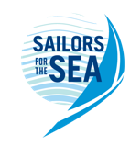

2022 OAKCLIFF TRIPLE CROWN SERIES

Proudly presented by Oakcliff Sailing

Stage 1: September 17-18 and Stage 2: September 24-25

NOTICE OF RACE

Abbreviations:
PC – protest committee | RC – race committee
OA – organizing authority | NA – national authority
RRS – racing rules of sailing | SI – sailing instructions
IJ – international jury | NOR – notice of race

RULES
  - The series will be governed by the rules as defined in The Racing Rules of Sailing.
  - The US Sailing Prescription to 63.2 will not apply.
  - RRS 44.1 and RRS P2.1 are changed so that the two-turn penalty is replaced by a one turn penalty. The sailing instructions may also change other racing rules.
  - ‘Athlete’, ‘competitor’ and ‘team’ mean a person or persons competing or intending to compete in the series.
  - Oakcliff Triple Crown Prize Grant Terms and Conditions as published on Oakcliff Sailing’s Website shall apply to all prize grants
  - [DP] Competitors and support persons shall comply with any reasonable request from an event official. Failure to comply may be misconduct. Reasonable actions by event officials to implement COVID-19 guidance, protocols or legislation, even if they later prove to have been unnecessary, are not improper actions or omissions.
  - Hearings conducted in accordance with RRS Part 5, Section B [Hearings & Decisions] shall be virtual hearings and parties and witnesses to such hearings shall have access to a device that has internet accessibility with audio and video capability; parties and witnesses must use audio and video in the presence of the protest committee. This supplements RRS Part 5, Section B [Hearings & Decisions]. See Information for Competitors posted on the Oakcliff Sailing website: oakcliffsailing.org/regattas/.
  - An IJ will be appointed in accordance with RRS Appendix N.

ADVERTISING
Boats may be required to display advertising chosen and supplied by the OA.

ELEGIBILITY AND ENTRY
  - Triple Crown Series events are open to boats of the 49er, 49erFX, Nacra 17, and 470 classes who have been issued an invitation by the OA. All classes are open to all genders to promote development of young sailors.
  - Invitations may be requested by completing the invitation request form available on the Oakcliff Calendar or Regatta Page: https://www.oakcliffsailing.org
  - Teams who receive an invitation may enter by following the instructions and adhering to the timing outlined on the invitation letter.
  - Late entries will be accepted at the discretion of the OA.
  - The following restrictions on the number of boats apply: Each class must have no less than four (4) boats registered for Triple Crown Series events to be given a start. Classes may be started together at the discretion of the OA.
  - Sailors that have outstanding balances with Oakcliff Sailing will not be scored until the outstanding balance is settled.

FEES
  - Each Triple Crown Series event as described in NOR 6.1 will have a non-refundable registration fee of $250. Late registrations accepted at the discretion of the OA, will have an entry fee of $300.
  - Other fees:
    - 49er, 49erFX, and Nacra 17’s are available for charter at a rate of $150 per day plus $50 per day for sails. A $50 surcharge will be applied if the charterer does not arrive to take possession of the boat before noon the day before racing starts.
    - Housing may be available on a first come first served basis at the rate of $35 for the 1st night and $25 for subsequent and contiguous nights on a per person basis. Please contact the OA at regatta@oakcliffsailing.org .

INVITATIONS
  - Invitations to each stage will be issued at the discretion of the OA and will take into consideration: US Sailing Team membership, resume and competitor performance at recent events.
  - Invitations will be issued to up to two (2) non-North American competitors and up to twelve (12) additional competitors per class, at the discretion of the OA.
  - The invitation committee may re-issue invitations that have not been accepted.
  - Invitations can be requested on the Oakcliff Calendar or Regatta Page: https://www.oakcliffsailing.org

PROVISIONAL SCHEDULE
  - Dates of Racing:
Stage 1 - September 17-18, 2022
Stage 2 - September 24-25, 2022
  - Provisional Schedule of each stage:
Friday 1000 Race office and boat park open
1700 Race office closes
Saturday 0900 Competitors’ Meeting at Oakcliff Beach
1100 First Signal
Umpire Debrief at 2 South St. as soon as possible after racing
Sunday 1030 First Signal
1500 No Warning Signal After
Post-Racing Refreshments on Oakcliff Beach for Pack-Up & Prize-Giving
  - Number of Races
    - 10 Races are scheduled per regatta
    - Up to 5 races may be sailed per day at the discretion of the RC

MEASUREMENT
  - All boats may be inspected for Class Rules compliance prior to racing. Boats can be randomly inspected for compliance at any time during the events. It is the competitors’ responsibility to meet all class equipment rules.
  - Equipment shall only be replaced with the written permission of the Jury.

VENUE

Racing will be held at Oakcliff Sailing on the waters of Oyster Bay, Cold Spring Harbor and/or Long Island Sound. See Attachment A - Venue and Racing Areas for the location of the venue and location of the racing areas.

THE COURSES
The courses will be windward/leeward style courses. Diagrams of the courses will be provided in the sailing instructions.

SCORING
  - Two (2) races are required to be completed each stage to constitute a regatta.
  - When fewer than five (5) races have been completed in that class, a boat’s regatta score will be the total of her race scores. When five (5) or more races have been completed, a boats regatta score will be the total of her race scores excluding her worst score.
  - If classes are started and sailed together, they will be scored as separate classes.

SUPPORT BOATS
  - Support boats shall be registered with the OA and follow all instructions given by the OA, RC and Umpires.
  - Violations of instructions given by the OA, RC, or Umpires are subject to a discretionary penalty by the Jury.
  - Violations that result in a benefit to their associated competitors, or make worse another competitor or any class, may result in the worsening of their associated competitors score at the discretion of the Jury.

RADIO COMMUNICATION
  - Except in an emergency, a boat that is racing shall not make voice or data transmissions and shall not receive voice or data communication that is not available to all boats.
  - Tracking devices and sensors that record or transmit data to a coach boat, that are used for post-race debriefs, and do not give feedback to sailors during the race, may be used.

PRIZES
  - The top three placing boats in each class will receive an Oakcliff prize.
  - Prize Grants will be awarded to the top 8 placing boats in each class.

Prize Grants are funds that sailors may use only for reimbursement of qualifying sailing expenses incurred after the date of winning the prize grant

Terms and Conditions, and information on how to redeem can be found on the Oakcliff website. Terms and conditions may change from time to time without notice, apply at the time of redemption, and have no independent cash value
    - Each class will have a $33,333 Prize Grant Pool per Triple Crown Series event as described in NOR 6.1 and subject to NOR 13.2.4.
    - The prize grants will be distributed for each event within the classes as follows: 1st – 45% ($15,000 per class, per event) 2nd – 25% ($8,333 per class, per event) 3rd – 10% ($33,333 per class, per event) and 4th through 8th - 4% ($1,333 per class, per event).
      - Eight (8) teams must compete in a class for that class to be eligible for the full prize pool for that regatta.
      - If four (4) or more teams but less than eight (8) teams in a class compete at an event, 50% of the prize grant pool will be allocated for that class in that event.
      - If less than four (4) teams compete in a class at an event, no prize grants will be awarded and the OA may or may not hold the event for those class(es).
      - Sailors eligible for qualification to the US Sailing Team will be allocated prize grant funds at 100% of distribution as described above. International sailors defined as any who are not or would not be eligible for qualification to the US Sailing Team shall be allocated prize grant funds at 50% of distribution.
      - Prize grant money will be split 50/50 between the crew and skipper unless the OA is notified in writing with signatures from both parties.

DISCLAIMER OF LIABILITY
Competitors participate in the race entirely at their own risk. See rule 3, Decision to Race. The OA, it’s associates, and appointees accept no responsibility for any loss, damage, injury, sickness, disease, or inconvenience incurred, however so caused. The failure of any of competitor to comply with any reasonable request of any Race Official or staff of the OA and its representatives may result in the disqualification of the boat, and its exclusion from the race.

MEDIA RIGHTS, CAMERAS AND ELECTRONIC EQUIPMENT
  - By participating in the Oakcliff Triple Crown Series, competitors automatically grant the OA, International 470, Nacra 17, the International 49er and 49erFX Class Associations and their sponsors, the right in perpetuity to make, use and show, from time to time at their discretion, any motion pictures and live, taped or filmed television and other reproductions of the athlete during the period of competition without compensation.
  - Boats may be required to carry cameras, sound equipment or positioning equipment as specified by the OA.
  - Competitors may be required for interviews and press conferences before and after racing at the Triple Crown Series events.

INSURANCE
Each participating boat shall carry valid insurance including third party liability coverage of at least USD $500,000 (or equivalent) per incident.

OAKCLIFF POLICY
Whenever you are representing Oakcliff Sailing it is expected that you will behave in a professional manner. Any time you are wearing Oakcliff Sailing Center or organization branded gear, at a sponsored event, at a sailing event as part of Oakcliff Sailing, at the Oakcliff Sailing Center, or on their boats, you are representing Oakcliff. The community at large and specifically the sailing community, sponsors and suppliers, and other employees and volunteers are to be treated with respect. There is to be no harassment or discrimination. No underage drinking or promoting of underage drinking or illegal drug use is permitted while you are on Oakcliff Sailing Center property or representing the Oakcliff Sailing Center.

FURTHER INFORMATION
  - Charter boats may be available upon request from Oakcliff Sailing. Interested parties can email highperformance@oakcliffsailing.org for more information.
  - For general logistics and planning information, please refer to Oakcliff’s website at https://www.oakcliffsailing.org/about-oakcliff/where-to-stay.
  - Organizing Authority - Oakcliff Sailing, 4 South Street, Oyster Bay, NY 11771
www.oakcliffsailing.org - race@oakcfliffsailing.org - (P) 516-802-0368 — (F) 516-802-3272
Race Program Director- Patrice Rachlin – regatta@oakcliffsailing.org
Executive Director - Dawn Riley - race@oakcliffsailing.org

Version: 3
August 20 2022

ATTACHMENT A – VENUE AND RACING AREAS

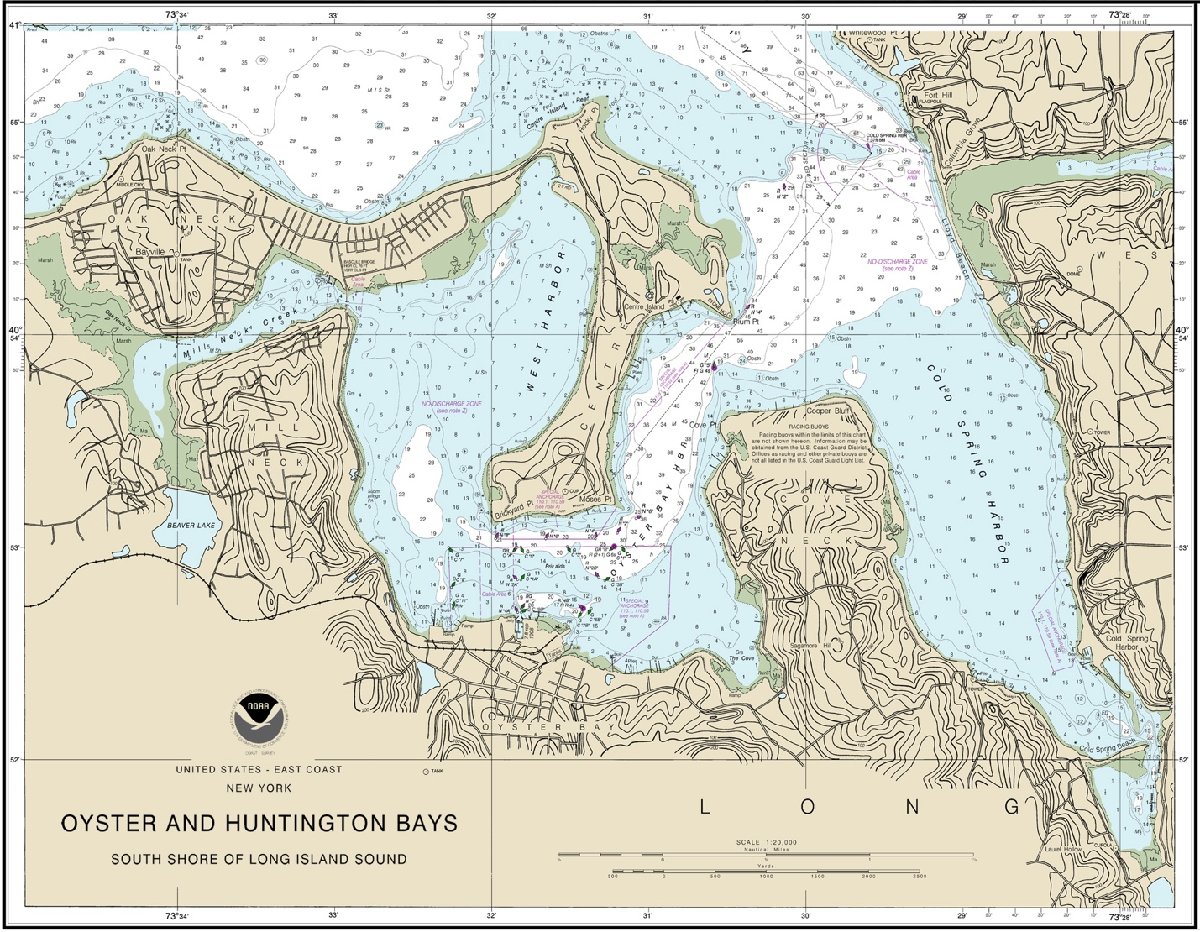

Main Hosting Venue:

Oakcliff Sailing
4 South Street
Oyster Bay, NY 11771

www.oakcliffsailing.org

(P) 516-802-0368 — (F) 516-802-3272

