QUESTIONS & ANSWERS – STERN POLES

The OA has affixed stern poles to the boats being used in this regatta in an effort to minimize damage to the boats during this competition. The following Q & A’s refer to the use of these poles.

QUESTION 1: Are stern poles, as attached to a boat by the OA at the forward end, part of the boat’s “equipment in normal position” for the determination of overlaps or contact?
Answer 1: Yes. See Match Race Call L4(2) & A4; DEFs: Clear Astern/Clear Ahead/Overlap.
NOTE: Stern poles are not part of a boat’s hull for purposes of rule 31 as modified in the Sailing Instructions.

QUESTION 2: Is a stern pole that is not in the position it was placed by the OA but
is still attached to the boat to be used to determine contact?
Answer 2: Yes. However, see Cases 77 & 91.

QUESTION 3: Is a stern pole that is not in the position it was placed by the OA to
be used to determine overlaps?
Answer 3: Yes, but only if the stern pole is still attached at the forward end and it is hanging over the stern. In all other instances, No . See Match Race Call A4 & A5; DEFs: Clear Astern/Clear Ahead/Overlap; Cases 77 & 91.

QUESTION 4: Are flags, cord, line or string attached to either or both of the stern
poles that are affixed to a boat considered to be part of the boat’s equipment for the
determination of overlaps or contact?
Answer 4: No. See Match Race Call L4(3).

QUESTION 5: Is a stern pole that is being dragged behind the boat by a string, cord or line to be used to determine contact or overlaps?
Answer 5: No. It is not attached to the boat.

QUESTION 6: Does contact occur if there is a breach of the box that is formed by the stern poles as placed on a boat by the OA and a projection of the hull to the same points below the ends of the stern poles (see lower diagram)?
Answer 6: Yes.

QUESTION 7: If one of the two stern poles is not in normal position, does contact
occur if there is a breach of the box described in Question 6?
Answer 7: Yes. See Question 6, Match Race Call G3, and the Diagram & Photo of the box below.

Bow

Stern Scoop

Stern Pole
Stern Pole

Box

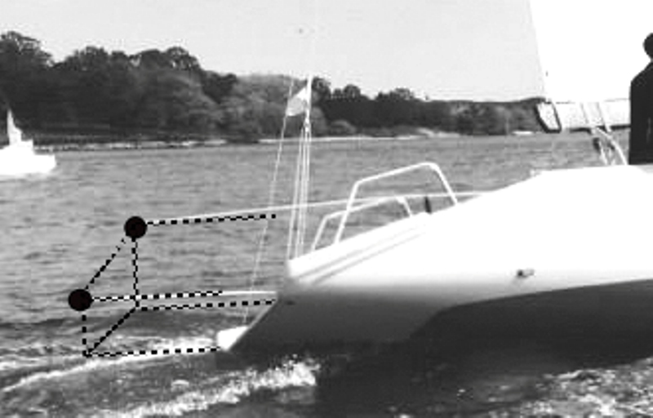

Chief Umpire
Oakcliff Sailing, 4 South Street, Oyster Bay, NY 11771 ~ 516-802-0368 ~ www.oakcliffsailing.org
V12.Dgrms

